Eliminating yellow fever epidemics in Africa: vaccine demand forecast and impact modelling
Short title : Modelling the Elimination of Yellow Fever epidemics in Africa

S2 Figure

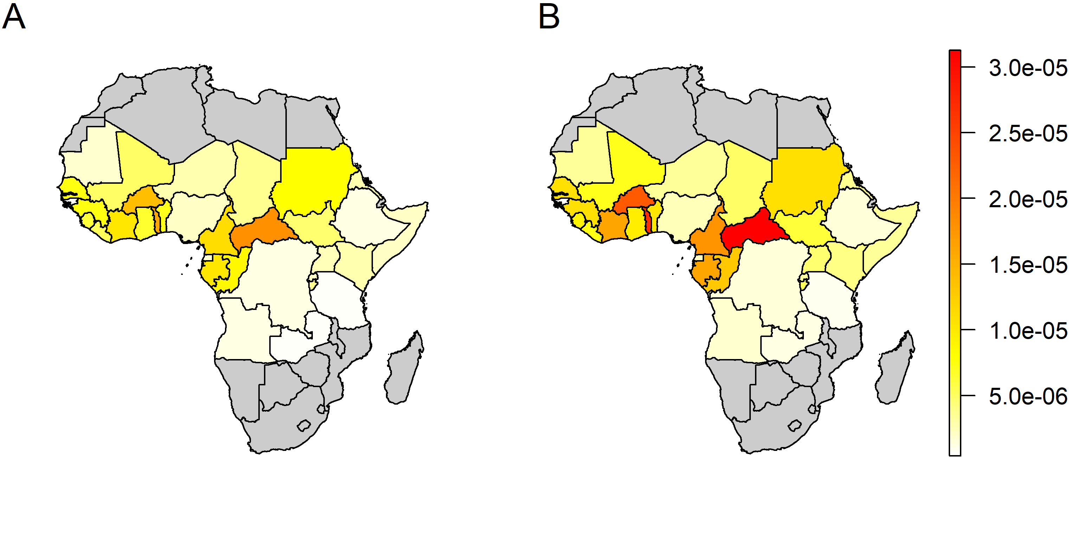
S2 Figure: Country-specific per-infection probability of detection across both model variants. A: FOI model, B: R₀ model. Maps were produced from GADM version 2.0.

