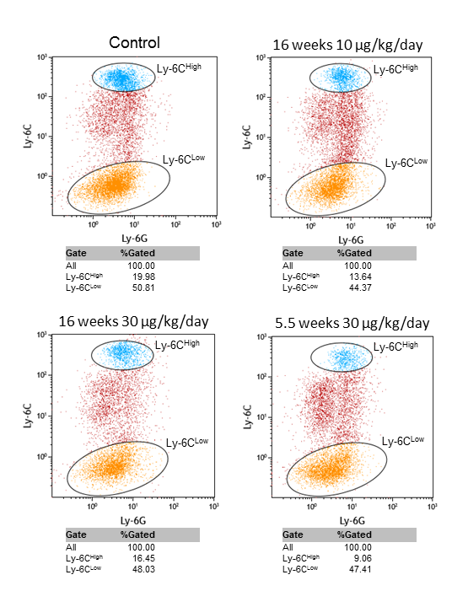

S2 Fig. Representative pictures of the distribution of the Ly-6C monocyte subsets. Based on the Ly-6C expression, monocytes were distributed into 3 monocyte subsets, the Ly-6C^{Low}, Ly-6C^{Intermediate} and Ly-6C^{High} monocyte subset.

